38.80: Each photon has momentum 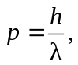 and if the rate at which the photons strike the surface is 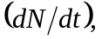 the force on the surface is 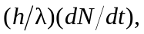 and the pressure is 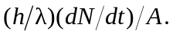 The intensity is
and comparison of the two expressions gives the pressure as 